Problems and questions - OSINT:

What is the technical idea behind OS fingerprinting?
OS fingerprinting identifies the operating system by observing how its TCP/IP stack implements protocol details as IP/TCP header fields (TTL, window size, DF flag), TCP options and order, ICMP responses and subtle quirks to crafted probes.
Those observable patterns form signatures that map to particular OSes/versions.

Why OS fingerprinting can be important for security?
Knowing the OS helps an attacker pick applicable exploits; defenders use it for asset inventory, vulnerability prioritization and detecting anomalous or unauthorized devices.
In short: it narrows the attacker’s choices and helps defenders focus patching and monitoring.

What is a difference between passive and active OS fingerprinting?
Active fingerprinting sends probes to the host and analyzes the replies (accurate but noisy/easily detected).
Passive fingerprinting only observes existing traffic from the host (stealthy but needs traffic and can be less complete).

Is it possible to protect your systems from OS fingerprinting?
Partially. You can harden and obfuscate (packet filtering, drop/normalize suspicious probes, disable TCP timestamps, tweak banners, use NAT/IDS/IPS or stack-randomizing tools) to make fingerprinting harder or produce ambiguous signatures, but you generally cannot make a host perfectly invisible to determined analysis.

Is it possible to fool intruder and to show him that your host is not alive?
Yes, if the host simply drops all probe packets (firewall rules that silently drop ICMP/TCP probes) it will often appear “down” or “filtered.” Note a sophisticated attacker may use alternate discovery methods or correlate other signals, so this is a mitigation, not a guaranteed deception.

What is DNS zone transfer and what is a risk related to this mechanism?
A DNS zone transfer (AXFR/IXFR) copies all zone records from a DNS master to a slave. If allowed to arbitrary outsiders, it leaks the domain’s entire DNS map (hostnames, subdomains, IPs, MX records, etc.), giving attackers a ready blueprint of the network.

Is it legal to use OSINT methods to get sensitive information?
Generally, OSINT (collecting publicly available information) is legal, but legality depends on jurisdiction and context.
Crossing into unauthorized access, scraping data against terms of service, privacy-law violations, or using deceptive/illicit means is illegal. Always check laws and policies.

What is the biggest threat in context of security and OSINT methods?
Human-targeted attacks (social engineering / spear-phishing) enabled by aggregated OSINT are the largest practical threat; small public facts combined let attackers craft convincing scams that bypass technical controls.

How to protect your sensitive data from OSINT search?
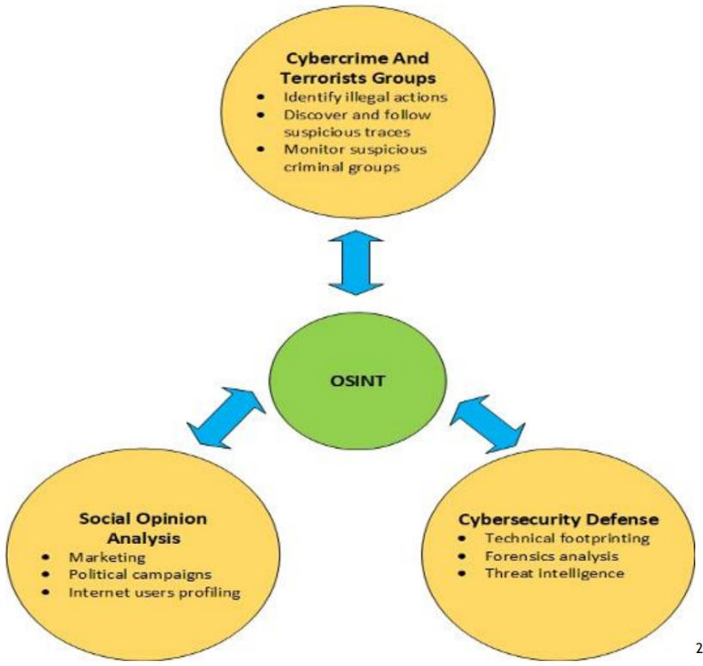
Reduce public exposure: lock down privacy settings, remove unnecessary PII from web profiles and documents, harden DNS (no open zone transfers), disable verbose service banners, use strong unique passwords + MFA, train staff on data hygiene, monitor for leaked data and use DLP/brand-monitoring services.

Tasks:

Select one well know domain (e.g. www.pwr.edu.pl) Try to gather some more specific information about the domain and its owner: e.g. who have registered the domain and when, till when it is valid, is it using cloudflare or other DDOS protection:
What to search for:
- WHOIS: registrant, registrar, creation & expiry dates, contact (GDPR may hide this).
- Name servers: indicate delegated DNS provider (Cloudflare etc).
- A/AAAA/MX/CNAME/TXT/SOA: infrastructure and mail handling.
- IP addresses and ASN: hosting provider and geographic hints.
- CDN/DDoS provider indicators: NS names, reverse DNS, certificate issuer, Cloudflare/Akamai signatures.
- Certificate transparency logs / crt.sh results for subdomains.
- Technology fingerprint (server, frameworks).

Query the whois database about that domain:

whois <domain> | tee <FileToStore>.txt
Check DNS servers as “nameservers”, its organization type, its creation date and more information of the servers.
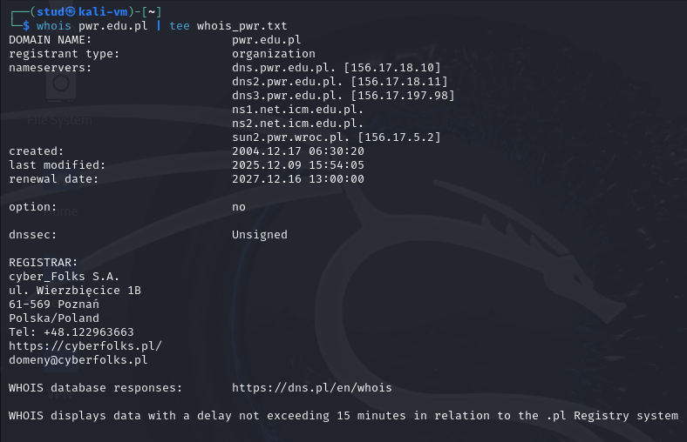

Collect information about the DNS servers and the corresponding records
of a target domain:

Use the host command line tool to lookup the IP address of a host from a DNS server:
host www.<domain> | tee <FileToStore>.txt
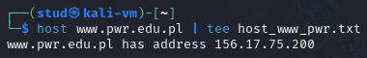
There you can see the Public Web Server hosting the university website: 153.17.75.200

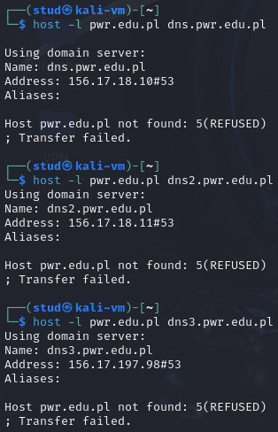
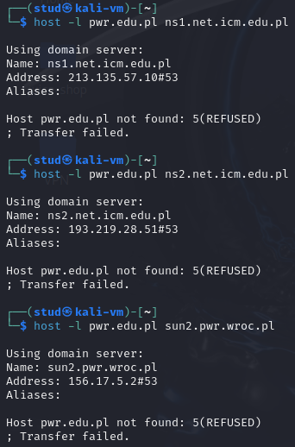
host -l <domain> <nameserver>

For all 6 authoritative nameservers: They refused the AXFR zone transfer and responded with error code 5 (REFUSED). This is the correct and secure behavior. As they do not expose internal DNS records.
- Use the dig command to do DNS interrogation
dig example.com any
dig @8.8.8.8 example.com
dig @8.8.8.8 example.com MX
dig -x 8.8.8.8 dig example.com +trace
dig +noall +answer
These dig queries are passive OSINT methods to collect publicly visible technical info about a domain: IPs, mail servers, authoritative name servers, subdomains, and hostnames. This info is used in information gathering / target reconnaissance before penetration testing or social engineering.

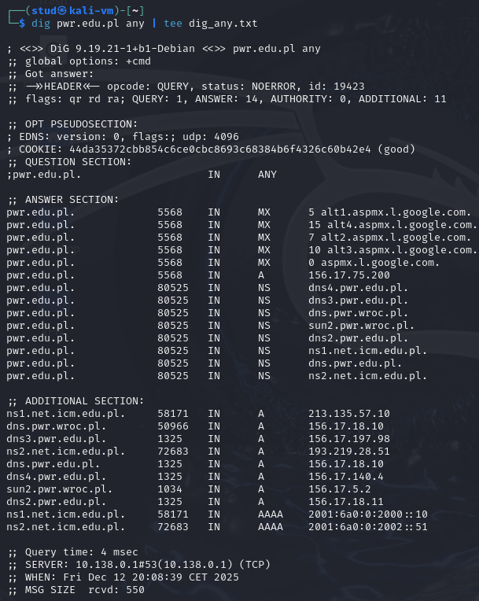
Run: > dig pwr.edu.pl any | tee dig_any.txt

Shows all publicly available DNS records (MX, NS, A) in one query. OSINT use: identify mail servers, name servers, and IP addresses that could be targeted for further info or mapping the network.

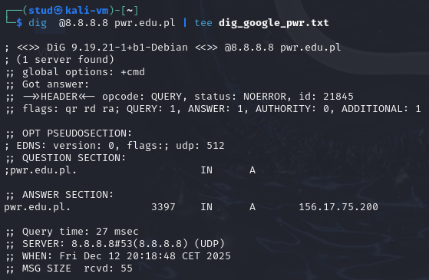
Run: > dig @8.8.8.8 pwr.edu.pl | tee dig_google_pwr.txt

Confirms the current public A record via a recursive resolver. OSINT use: check publicly visible IP, see what external users see, detect caching or CDN.

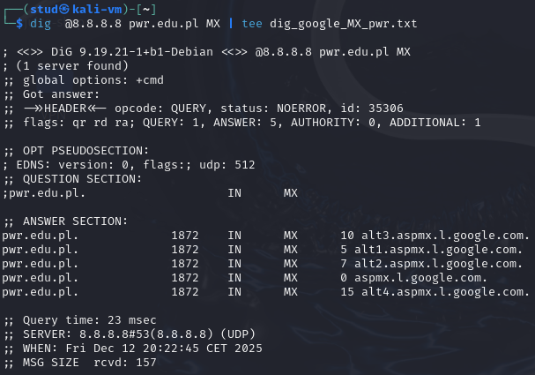
Run: > dig @8.8.8.8 pwr.edu.pl MX | tee dig_google_MX_pwr.txt

Reveals mail infrastructure (Google mail servers in this case). OSINT use: useful for phishing, social engineering, or mail server enumeration.

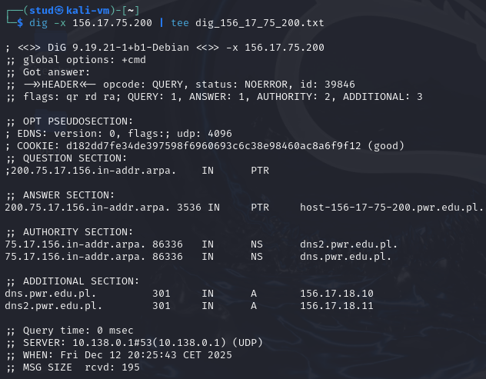
Run: > dig -x 156.17.75.200 | tee dig_156_17_75_200.txt

Reverse DNS lookup links IP -> hostname. OSINT use: can map hosts to domain names, verify IP ownership, or find subdomains.

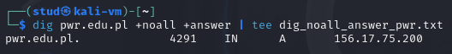
Run: > dig pwr.edu.pl +noall +answer | tee dig_noall_answer_pwr.txt

Quick, clean info on live IPs and TTL. OSINT use: assess live targets, caching, and network exposure for reconnaissance.

Run: > dig pwr.edu.pl +trace | tee dig_trace_pwr.txt
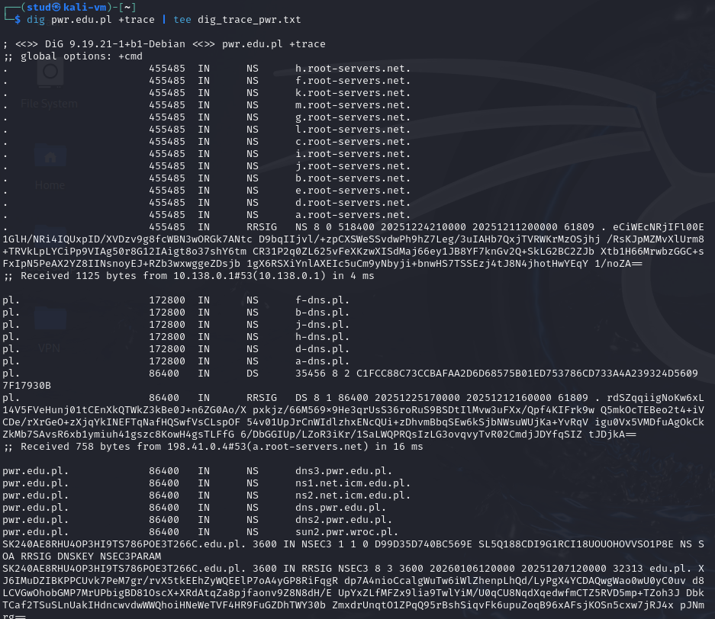
Shows full delegation path from root -> TLD -> authoritative NS. OSINT use: shows which NS control the domain, can identify potential weak points or secondary NS.

Find the primary DNS for a given domain
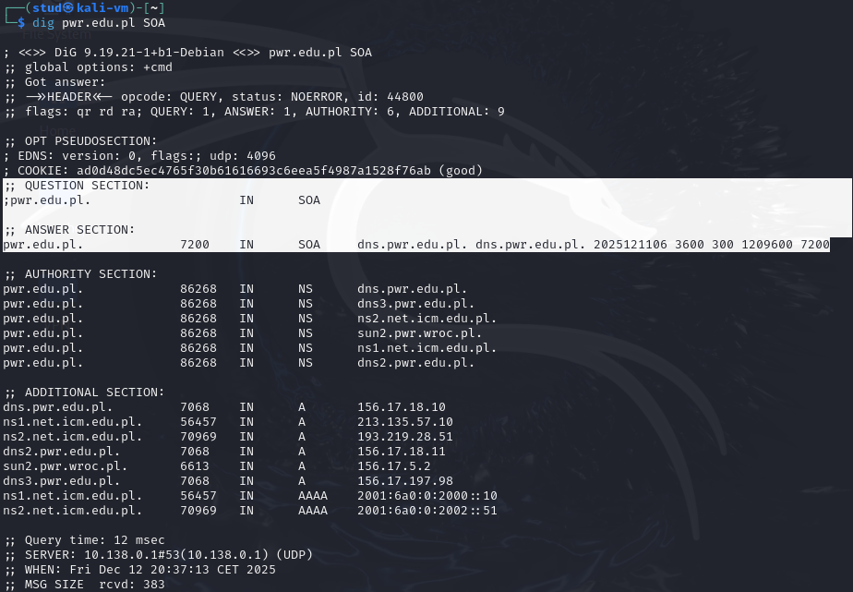
To find the authoritative DNS server of the university you need to run: > dig pwr.edu.pl SOA

So the principal DNS server is: dns.pwr.edu.pl with:
- Serial: 2025121106 (YYYYMMDD of last update)
- Refresh: 3600 (sec = 1 hour)
- Retry: 300 (sec = 5 min)
- Expire: 1209600 (sec = 14 days)
- Min TTL: 7200 (Default caching time)

Try to find out what is TTL and if the requested domain was cached by DNS.
TTL (Time To Live) is the number of seconds a DNS record is allowed to stay in a DNS resolver’s cache before it must ask the authoritative DNS server again.
- High TTL -> cached longer
- Low TTL -> refreshed more often
How to find it: when running dig pwr.edu.pl
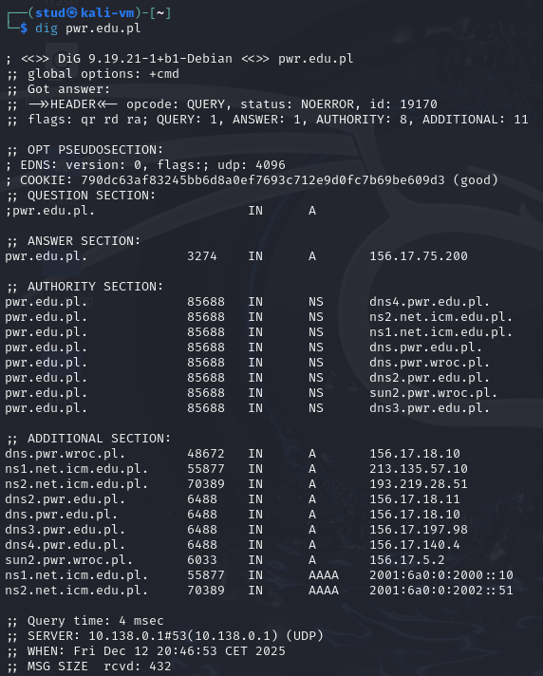
In the line: pwr.edu.pl. 3274 IN A 156.17.75.200
The observed TTL will keep going down until it reaches 0 and another request is sent and caught again.
For example, on the line: pwr.edu.pl. 85688 IN NS dns.pwr.wroc.pl.
85688 (sec) means that it remains in cache memory for 23 more hours until another request is sent.

Find out how long time ago the given domain was requested at some DNSs (e.g. 1.1.1.1, 8.8.8.8, local DNS,…)
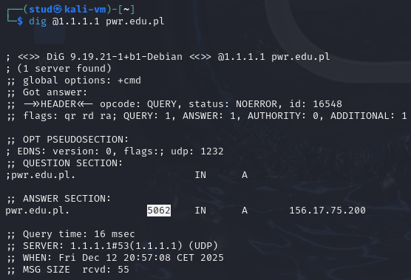
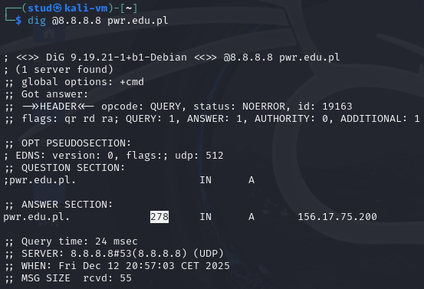
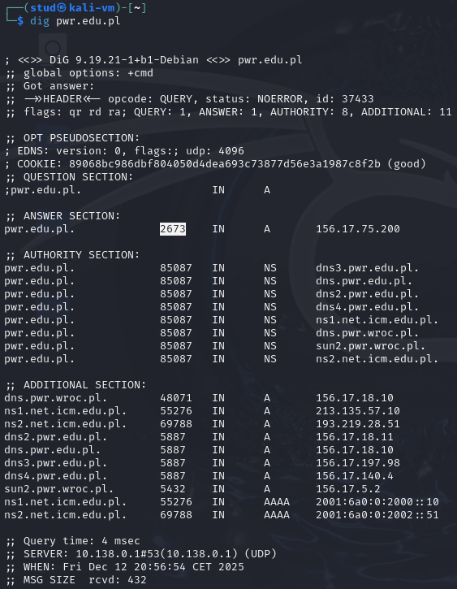
You can write several commands: > dig @x.x.x.x <dom ain> or for local: > dig <domain>
As we know that: Authoritative TTL = 7200 seconds

The formula is $Cache age [sec]=7200 \left[sec\right]-Remaining TTL [sec]$
For Local DNS: $Cache age=7200-2673=4527 s ≈1 hour and 15 minutes ago$
For 8.8.8.8 (Google): $Cache age=7200-278=6922 s ≈1 hour and 55 minutes ago$
For 1.1.1.1 (Cloudflare): $Cache age=7200-5062=2138 s ≈36 minutes ago$

This is proof that you are seeing cached answers, not fresh ones.

Utilize dnsenum dnsenum example.com dnsenum -f dns.txt example.com:
dnsenum performs multi-technique DNS enumeration: queries NS, MX, SOA, does brute-force subdomain lookups (wordlist based), reverse lookups on discovered nets, and attempts zone transfer tests.
To run it you must use the command: > dnsenum pwr.edu.pl | tee dnsenum_pwr.txt
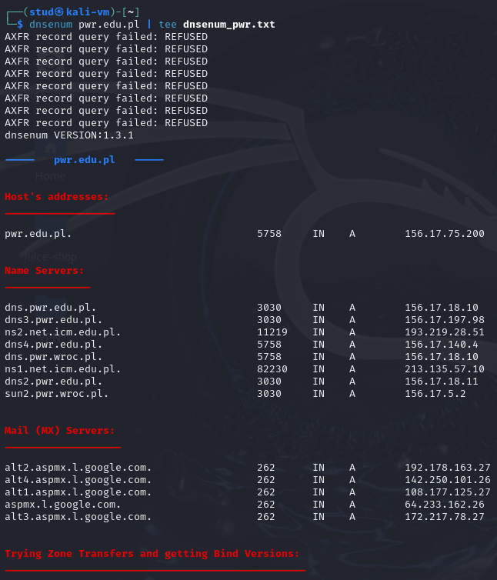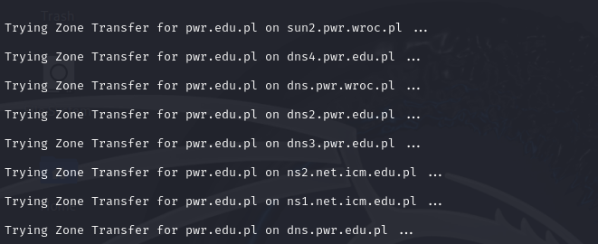
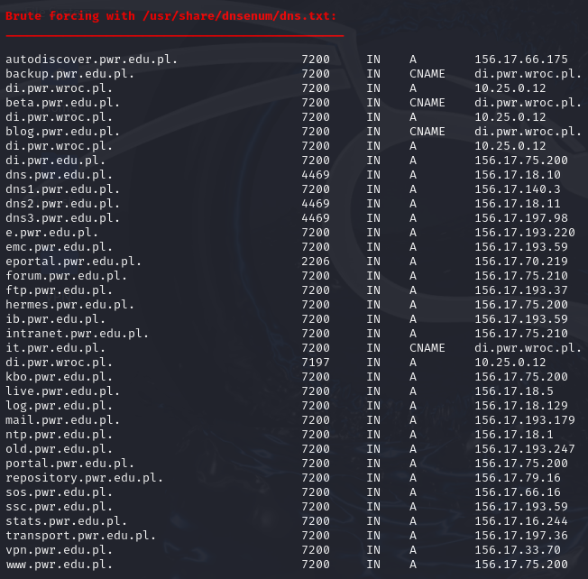
A = final IP
CNAME = pointer to another name
…
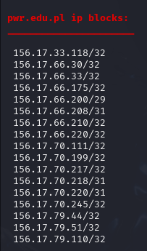
And run also the command: > dnsenum -f /usr/share/dnsenum/dns.txt pwr.edu.pl <domain> | tee <FileNameWhereToStore>
That writes the hosts given dns.txt:
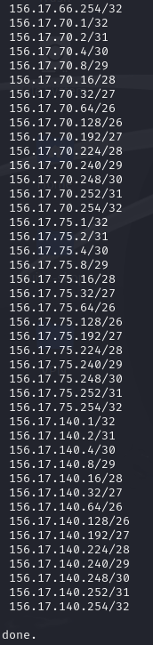

With this attack we can identify additional parts of the domain infrastructure such as CNAME links and host IP addresses:
- autodiscover.pwr.edu.pl -> 156.17.66.175 ; www.pwr.edu.pl -> 156.17.75.200 (from log: dnsenum_f_pwr)
- Several hosts are resolved via the CNAME di.pwr.wroc.pl to an internal address 10.25.0.12, which indicates internal naming information leakage through DNS CNAME records (from log: dnsenum_f_pwr)
- Other publicly reachable services were identified, e.g. mail.pwr.edu.pl -> 156.17.193.179, ftp.pwr.edu.pl -> 156.17.193.37, vpn.pwr.edu.pl -> 156.17.33.70, etc.
This information allows mapping exposed services and understanding how internal and external DNS naming is structured, which is useful for further reconnaissance.

Find all of the IP addresses and hostnames of a target fierce -dns example.com -threads 3:
Running the command: > fierce -dns pwr.edu.pl -threads 3 | tee fierce_pwr.txt, as we need the new version prompt we write > fierce --domain pwr.edu.pl | tee fierce_pwr.txt
What fierce does:
- Enumerates hostnames / subdomains via DNS.
- Detects parent netblocks and “nearby” addresses (hosts in the same subnets).
- Tests for wildcard DNS behavior and attempts zone transfers (AXFR).
- Produces candidate IP ranges to target with active scanning tools (Nmap, vulnerability scanners).

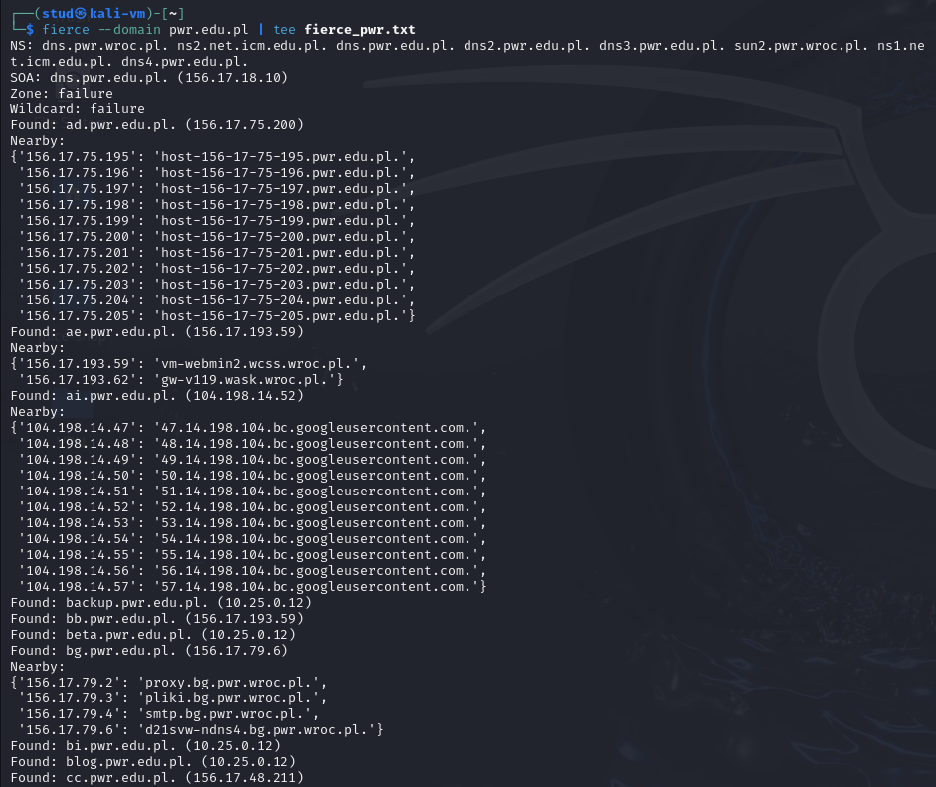
…
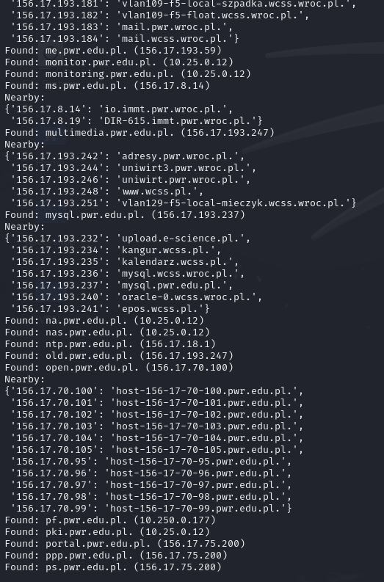
The scan revealed authoritative DNS servers (e.g. dns.pwr.edu.pl, ns1.net.icm.edu.pl), confirmed AXFR and wildcard DNS failures, and enumerated many subdomains with IPs (e.g. ad.pwr.edu.pl -> 156.17.75.200, ai.pwr.edu.pl -> 104.198.14.52).
It also identified multiple public netblocks (e.g. 156.17.75.*, 156.17.193.*) and exposed private/internal addresses in DNS (e.g. backup.pwr.edu.pl -> 10.25.0.12, guest.pwr.edu.pl -> 10.250.13.254).

Get network routing information:
- Using tcptraceroute traceroute www.example.com
Run the command: > sudo tcptraceroute pwr.edu.pl | tee tcptraceroute_pwr.txt
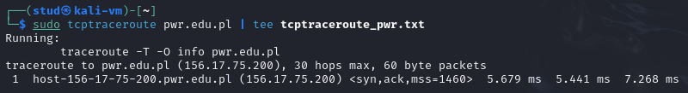
The trace reached pwr.edu.pl (156.17.75.200) in one hop, with a TCP SYN/ACK response and low latency (~5–7 ms). This indicates that the destination is either on the same local network (I am not on it) or that intermediate routers/firewalls do not return TTL-exceeded messages for TCP probes, causing only the final host to appear in the trace.

- Using tctrace tctrace -i <network_interface> -d <target_host>
After checking the internet network in my case eth0: given the command > ip a
Run the command: sudo tctrace -i eth0 -d pwr.edu.pl | tee tctrace_pwr.txt
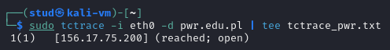
The output shows the target 156.17.75.200 as reached; open in a single hop. This confirms successful TCP connectivity to the destination and that the probed TCP port is open, while intermediate routing devices do not expose their hop information.

Summarize your findings, compare tools and obtained results. What type of information do they provide? How malicious user can benefit from this type of information? Which tool is the most versatile?
What we got
- DNS & hosting: authoritative nameservers, SOA and TTLs confirmed; public A records show the main IPs for pwr.edu.pl.
- Public hosts / subdomains found: web, mail, vpn, ftp and many other subdomains were enumerated (a ready map of public-facing services).
- Information leakage: some DNS records (CNAMEs) reveal internal names / private Ips, accidental exposure of internal structure.
- Reachability: several discovered hosts are directly reachable from the Internet (low latency, respond to TCP probes).
- OSINT: public emails and documents indexed on the web were collected (useful for profiling and phishing).
- Main risks: leaked internal names, multiple externally exposed services, and harvestable emails/documents that enable social engineering.

Tools vs results (what each tool gave us):
- dig / host -> authoritative DNS records (A, MX, NS, SOA, TTLs).
Good for facts about domain delegation and TTLs.
- dnsenum / fierce -> large list of subdomains, reverse lookups, AXFR checks, and discovery of CNAMEs that leak internal names.
- tcptraceroute / tctrace -> reachability and rough network path/latency for specific TCP services.
- theHarvester -> harvested email addresses, indexed documents and other publicly exposed content useful for profiling.
- Shodan / Censys (workflow step) -> how to check which services/ports are exposed globally and whether known vulnerable versions appear.

What info these tools provide, how it helps attackers and defenders, and the most versatile tool:
The tools deliver three main kinds of information: (1) structural facts about the domain (nameservers, TTLs, delegation), (2) an inventory of public hosts/services (subdomains, IPs, open TCP services), and (3) people/content intelligence (emails, indexed docs).
- A malicious user can use that information to build a target list, craft phishing/spear-phishing, look for exposed services with known CVEs, and map internal naming conventions.
- A defender uses the same outputs to find accidental leaks (fix CNAMEs), reduce unnecessary public exposure, prioritise patching (by mapping service versions -> CVEs), and to harden access (bastions, IP restrictions, MFA, remove public docs).

The most versatile tool from our work is dnsenum because it combines many DNS techniques (subdomain discovery, reverse lookups, AXFR tests) and produces the richest, immediately actionable map of hosts. So, it is great for both comprehensive reconnaissance and for defenders doing an exposure audit.

Try to find some Vulnerable Files or sensible information using google hacking method (e.g. in domain pwr.*.edu.pl or in some other domain):
    - Search for documents files (.doc, .docx, .txt, .xls, pdf,….)
For that you can add the query: > site:pwr.*.pl filetype:pdf OR filetype:docx OR filetype:doc OR filetype:xlsx OR filetype:xls OR filetype:txt
Into the browser so it shows you any file given that specific format.
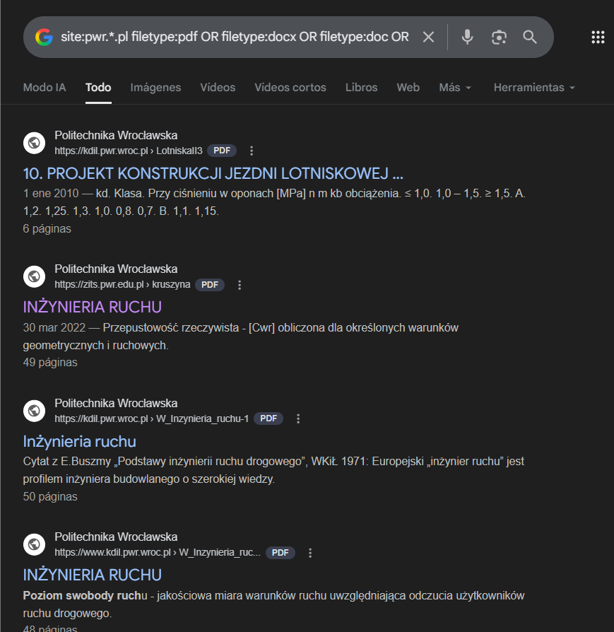
It is used to locate publicly accessible documents.
These searches returned lecture notes, administrative documents, presentations, and reports, some of which were not intended for broad public access.
There are several examples: “INŻYNIERIA RUCHU”.pdf, or “wytyczne do projektowania pomieszczeń”

    - Search for documents with some specific content (e.g. grade, password, points, addresses, …)
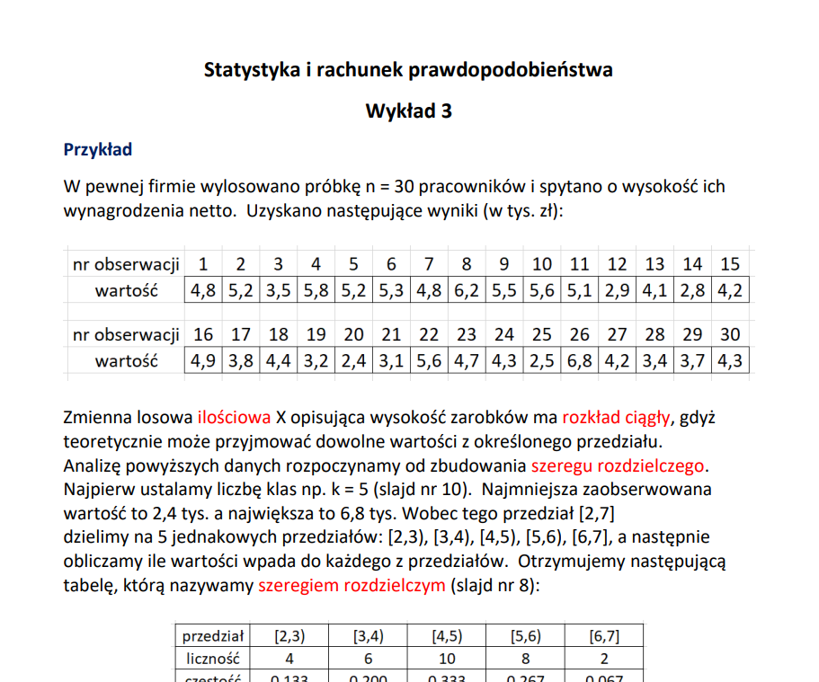

You can in this part expand what was told before with: > site:pwr.*.pl filetype:pdf grade
Where you can see files as “Statystyka i rachunek prawdopodobieństwa”
Or with site:pwr.*.pl address or site:pwr.*.pl password


    - Create statistics of findings (number of files, number of IP addresses, number of users, …)
For the site:pwr.edu.pl with a total number of 509 000 results, from those, when filtering by type:
filetype: | pdf | doc | docx | xls | xlsx | txt
# of results | 61100 | 1600 | 3630 | 241 | 678 | 462

Files containing the keywords:
Keyword | “password” | “grade” | “exam” | “address” | “student” | “login”
# of results | 909 | 2890 | 3420 | 6660 | 19500 | 11600

To check all the numbers you click on “Herramientas” (Tools) and it says 19.500 aprox.
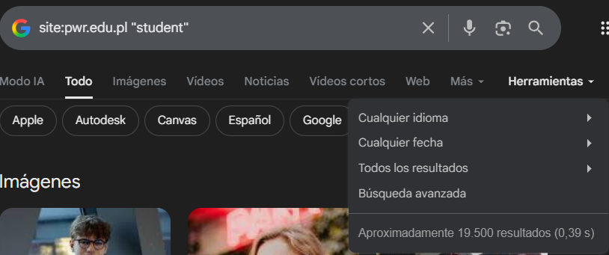

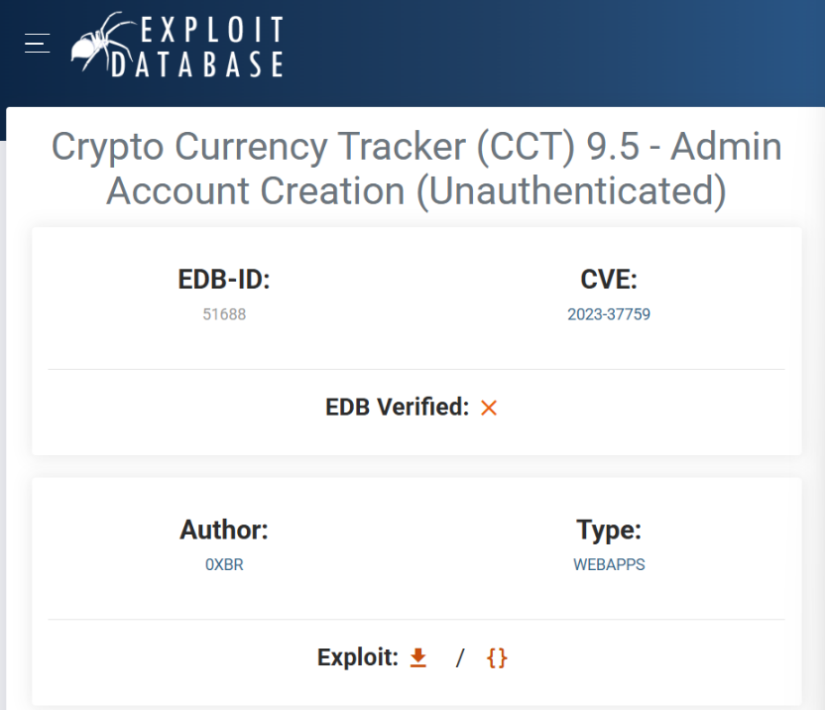
    - Find some interesting data using selected dorks from https://www.exploit-db.com/google-hacking-database/
The Google Hacking Database (GHDB) on Exploit-DB contains numerous dorks that can uncover sensitive data. For example, intitle:"index of" "parent directory" reveals open directories with potentially sensitive files, while inurl:admin intitle:"login" identifies unprotected admin login pages. Dorks like filetype:log "password=" can expose log files containing passwords, and inurl:"server-status" finds exposed Apache server-status pages revealing server details.

Use theharvester to collect e-mail accounts, username, and hostname/subdomains: theharvester -d example.com -l 100 -b linkedin for a given domain name try to search data using different data sources (e.g. baidu, bing, yahoo or use all):
To use theHarvester we need to use this form: theHarvester -d <domain> -l <limit> -b <source>:
Where domain is pwr.edu.pl, the limit is 200 results per source, and the sources are:
Domain | bing | duckduckgo | baidu | yahoo | otx | certspotter
IPs | - | - | - | - | - | -
Emails | - | - | 10 | 7 | - | -
Hosts | - | 30 | 5 | 10 | - | 1

Domain | anubis | rapiddns | sitedossier | subdomaincenter | subdomainfinderc99 | threatminer
IPs | - | - | - | - | - | -
Emails | - | - | - | - | - | -
Hosts | - | 2234 | - | 489 | - | -

Domain | dnsdumpster | urlscan | hackertarget | crtsh
IPs | - | 19 IPs  45 URLs | - | -
Emails | - | - | - | -
Hosts | - | 34 | 934 | -
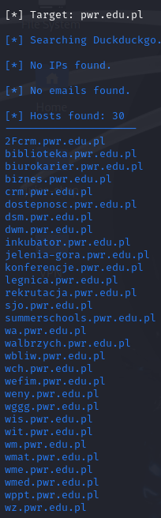
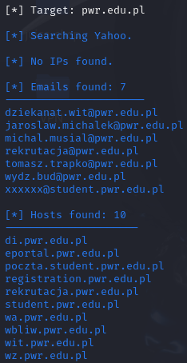
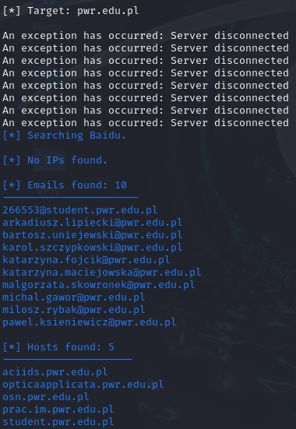
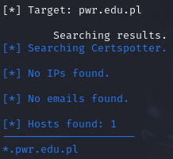
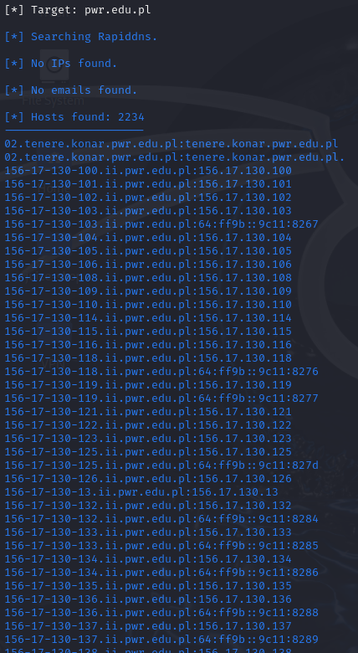
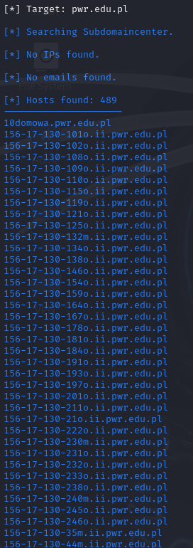
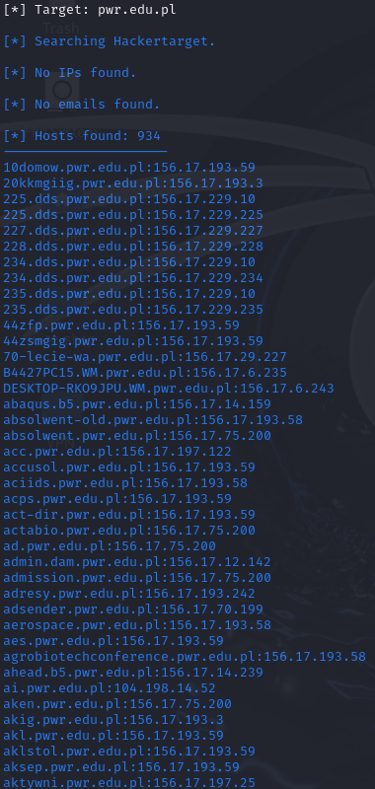

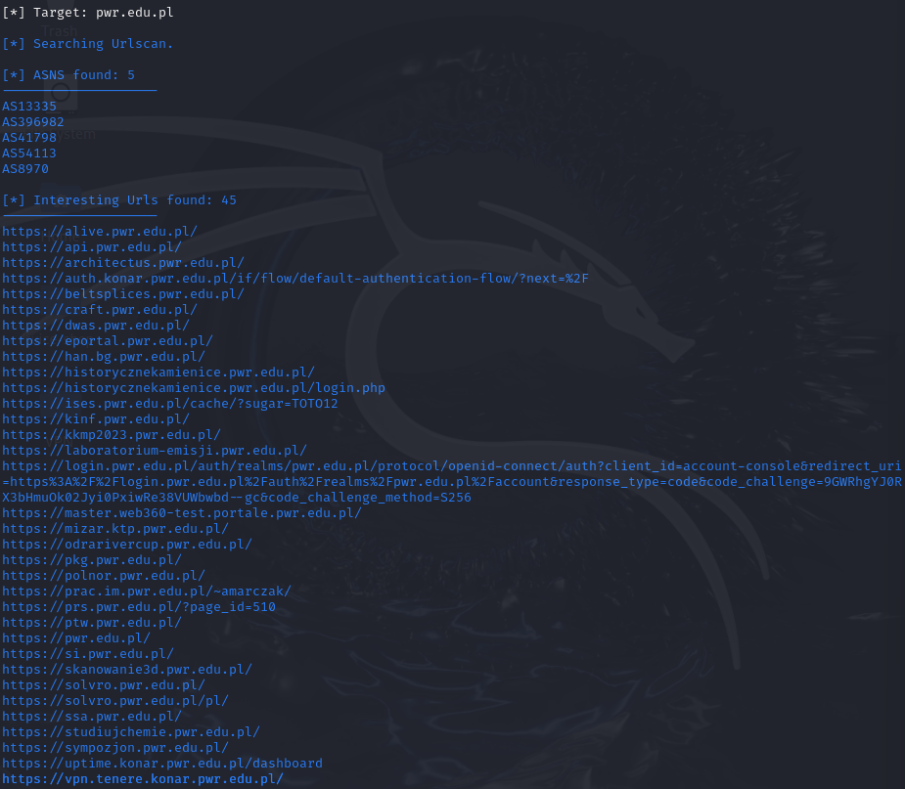
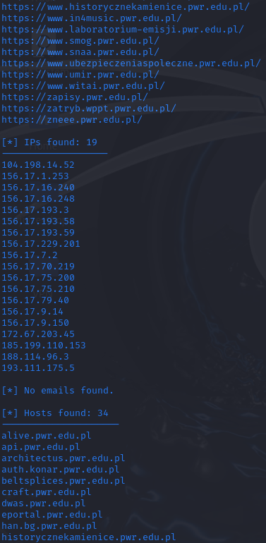

Using https://nvd.nist.gov/vuln/search search for some vulnerabilities in some type of the service (ssh, ftp, ssl, apache, qnap, western digital …) and in next query related to some device (e.g. wireless router, asus wireless router, tp-link). Find some specific problem related to this service (device) – it is described as CVE – year – number. Find critical vulnerabilities. Describe the vulnerability. Find the link to the webpage with exploit or/and detailed description of the vulnerability:
Search by service, example ssh critical:
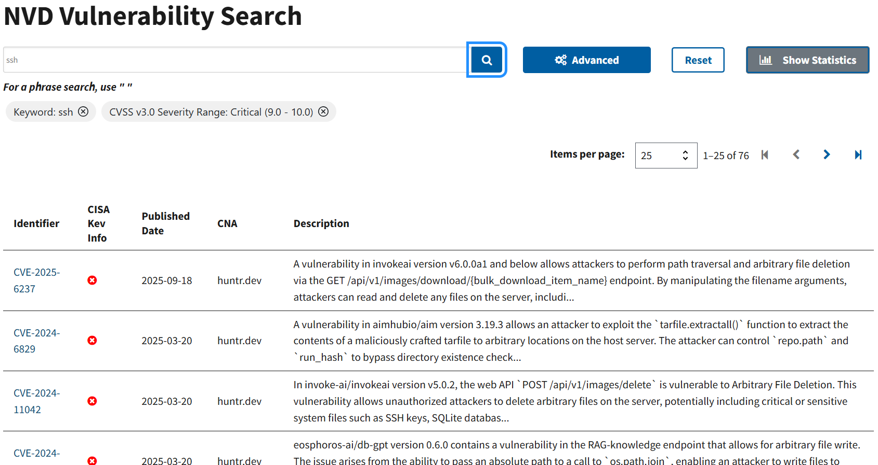
Or for type of device, example wireless router:
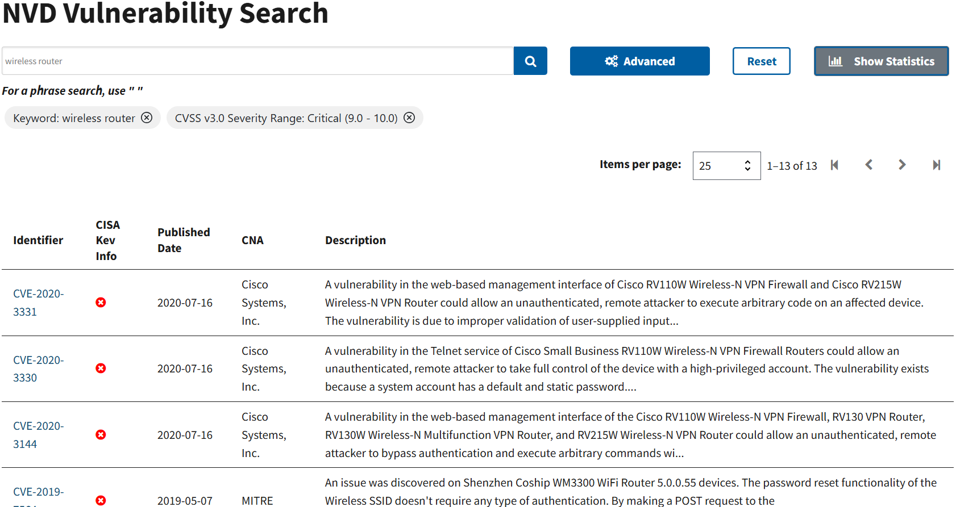
I chose the first vulnerability that appeared:
CVE-2025-6237 - Path traversal & arbitrary file deletion in InvokeAI
CVE ID: CVE-2025-6237
Published: 2025-09-18.
Severity: CRITICAL - CVSS (CNA) 9.8 / 9.3 (different systems show 9.3–9.8).
Summary:
An unauthenticated path-traversal vulnerability in the InvokeAI bulk downloads API lets an attacker read and delete arbitrary files on the server by supplying crafted values to the bulk_download_item_name parameter.
Affected software version(s):
invoke-ai / InvokeAI: versions < 6.7.0 are affected. The issue is fixed in 6.7.0.
Detailed description:
The vulnerable endpoint is: GET /api/v1/images/download/{bulk_download_item_name}. The server concatenates the user-provided bulk_download_item_name into a filesystem path without canonicalizing or validating it. By including traversal sequences (e.g. ../) or absolute paths the attacker can escape the intended media directory and access or remove arbitrary files (SSH keys, DB files, configs, etc.). In some back-end/storage configurations this also enables overwriting or deletion of files referenced by the crafted path. CWE mapping: CWE-22 (Path Traversal) / CWE-73 (External Control of File Name or Path).
Impact & exploitability:
- Impact: Confidentiality, Integrity and Availability - attacker can read secrets (e.g., SSH keys), delete databases or configs, or otherwise disrupt the service.
- Exploitability: Network-accessible, requires no authentication, and has low complexity - trivial path-traversal strings are sufficient per advisory descriptions. That’s why it’s rated critical.
Direct references:
- NVD: CVE-2025-6237.
- GitHub Advisory (GHSA-vv9c-xxg7-wmv7) - includes link to the repo file and release.
- Vulnerable source file (example location in v6.0.0a1): invokeai/app/api/routers/images.py - lines referenced by advisories. Inspecting that file shows the code path that builds the download path.
- Huntr disclosure (original bounty/report): huntr.com bounty page.
- https://cwe.mitre.org/data/definitions/73.html

Using results from the previous point (e.g. openssh 7.7 is vulnerable) search for the systems with this vulnerability (from point X) using
- https://censys.io
- https://www.shodan.io
- https://zoomeye.org
Write how many vulnerable systems have been found. Which countries are the ‘top most’ vulnerable?
Now we must check using Shodan, find systems exposing the InvokeAI endpoint that is vulnerable to CVE-2025-6237 and report counts and top countries.
We start by creating an account in shodan and > shodan init <api key>
I executed the following searches on Kali/terminal and via Shodan:
- Check for the exact vulnerable endpoint: shodan count 'http.html:"/api/v1/images/download"'
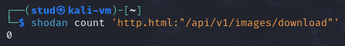
- Search for general InvokeAI fingerprint (title / body):
shodan count 'http.title:"InvokeAI"' / shodan count 'http.html:"InvokeAI"'
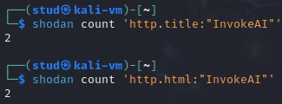
- Attempt to list host details (IP / country):
shodan search --fields ip_str,port,location.country_name,org 'http.title:"InvokeAI" OR http.html:"InvokeAI"' --limit 1000
The error is a Shodan plan restriction preventing host-level exports from the current account (I have a free one).

Summary:
- shodan count 'http.html:"/api/v1/images/download"' → 0
- shodan count 'http.title:"InvokeAI"' → 2
- shodan count 'http.html:"InvokeAI"' → 2
- Attempting shodan search to list IPs/countries returned 403 Forbidden (free-tier limitation), so host metadata could not be exported from the CLI.

2 potentially exposed InvokeAI instances were found by Shodan. These two hosts are potentially vulnerable. Confirmation requires authorized version checks or safe manual testing.
Country-level information could not be retrieved from the current Shodan CLI session because shodan search/export is blocked by the account (403 Forbidden).
Therefore I cannot reliably list the top countries from the CLI output.
Finally, Shodan’s results indicate potential exposure only; confirming CVE-2025-6237 requires authorized testing (version check, safe endpoint probes) on systems you own or are permitted to test. Never attempt exploitation on systems you do not control.

